Assignment # 2
Dania Khan
23k-0072

Q1)

A) Entities and Attributes
Entity: FILM
- FilmID (Primary Key)
- Title
- Budget
- ReleaseDate
- DirectorName
Entity: ACTOR
- ActorID (Primary Key)
- Name
- Phone
Entity: PRODUCTION_COMPANY
- CompanyID (Primary Key)
- Name

B) Main Relationships and Cardinality
- FILM ACTOR
  - Relationship: Films cast actors
  - Cardinality: Many-to-Many (M:N)
- FILM – PRODUCTION_COMPANY
  - Relationship: Production companies fund films
  - Cardinality: Many-to-Many (M:N)
- FILM – Director
  - Relationship: Films are directed by directors
  - Note: Not implemented as a separate entity. Director information is stored as an attribute (DirectorName) in the FILM entity.

C) Associative Entity for M:N Relationship
Associative Entity Name: CASTING
Attributes:
- FilmID (Foreign Key → FILM, part of Primary Key)
- ActorID (Foreign Key → ACTOR, part of Primary Key)
- CharacterName
Primary Key: (FilmID, ActorID)

D) Explanation
Since each film is made by exactly one director and no other director-related information (such as ID, contact, or multiple films per director) is tracked, creating a separate Director entity would be unnecessary.
Storing DirectorName directly in the FILM table is more efficient because:

Q2
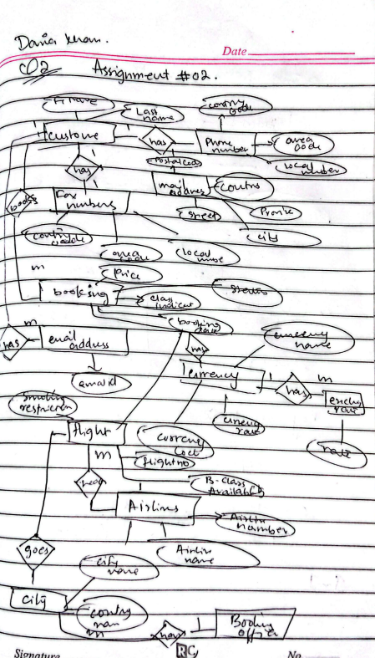
Q3
A) Update Anomalies
1. Insertion Anomaly: We cannot insert information about a new school unless at least one teacher has worked there.
Example: If “Bluebell School” in “Leeds” is added but no teacher has yet worked there, it cannot be inserted without teacher data.
2. Deletion Anomaly: If a teacher record is deleted, information about the school could be lost.
Example: If the two records for “Green School” (Birmingham) are deleted, all data about that school disappears from the table.
3. Update Anomaly: If a school name or city changes, it must be updated in multiple rows, leading to inconsistency.
Example: If “Park School” in “Manchester” changes its name, all rows with S301 must be updated. Missing one causes inconsistent data.

B) Normalization to 3NF
Functional Dependencies
- NIN → tName
(Each teacher’s name depends on their unique National Insurance Number)
- schoolID → schoolName, schoolCity
(Each school ID determines its name and city)
- (NIN, schoolID, contractNo) → hours
(The combination of teacher and school determines hours and contract details)

1st Normal Form (1NF)
The table is already in 1NF because all values are atomic (no repeating groups).
2nd Normal Form (2NF)
To achieve 2NF, removing partial dependencies.
Partial dependencies:
· NIN → tName
· schoolID → schoolName, schoolCity

Teacher Table:
NIN | tName
2103 | Brown A
2198 | Khan R
2205 | Lewis H

School Table
schoolID | schoolName | schoolCity
S301 | Park School | Manchester
S114 | Green School | Birmingham

Work Table:
NIN | contractNo | schoolID | hours
2103 | T9001 | S301 | 10
2198 | T9001 | S301 | 18
2205 | T9001 | S114 | 20
2103 | T9001 | S114 | 12

Q4

A. Primary Key
According to the fourth functional dependency, only the combination of FilmID and ActorID can determine all the other attributes in the table. Therefore, the Primary Key of the FILM_CASTING table is:
Primary Key: (FilmID, ActorID)

B. Normal Form Violation
Although the table is in First Normal Form (1NF), it violates Second Normal Form (2NF).
This is because some non-key attributes depend only on a part of the composite key rather than the whole key. For example:
- FilmID → FilmTitle, DirectorName
- ActorID → ActorName, AgentID
These are partial dependencies, and such dependencies violate 2NF.
Therefore, the highest normal form violated is 2NF.

C. Decomposition to 2NF
To remove partial dependencies, we separate the attributes that depend only on FilmID and only on ActorID.
After decomposition into 2NF, the tables become:
- FILM(FilmID, FilmTitle, DirectorName)
(removes dependency FilmID → FilmTitle, DirectorName)
- ACTOR(ActorID, ActorName, AgentID)
(removes dependency ActorID → ActorName, AgentID)
- FILM_CASTING(FilmID, ActorID)
(Only keeping the relationship will cause inconsistent data.
- This is known as an Update Anomaly. between films and actors)

D. Decomposition to 3NF
In the ACTOR table, there is still a transitive dependency:
AgentID → AgentPhone
To remove this, we create a separate AGENT table.
Final tables in 3NF:
- FILM(FilmID, FilmTitle, DirectorName)
  - Primary Key: FilmID
- ACTOR(ActorID, ActorName, AgentID)
  - Primary Key: ActorID
  - Foreign Key: AgentID references AGENT
- AGENT(AgentID, AgentPhone)
  - Primary Key: AgentID
- FILM_CASTING(FilmID, ActorID)
  - Primary Key: (FilmID, ActorID)
  - Foreign Keys: FilmID references FILM, ActorID references ACTOR
Q5
A) Functional Dependencies
· Student ID → First Name, Last Name, Address
(One student has one name and one address.)
· Course ID → Course Name, Credits, Instructor Name
(Each course has one title, one credit value, and one instructor.)
· Student ID, Course ID → Enrollment Date
(A student enrolls in a specific course on a particular date.)

Assumptions made:
· A course is taught by exactly one instructor.
· A student has only one address recorded in the system.
· A student can enroll in a given course only once (so (Student ID, Course ID) is unique for enrollments).

B) Normalization to 3NF
1NF:
· Table is already in 1NF (atomic values).
2NF:
· Composite key: (StudentID, CourseID) in the enrollment table
· Partial dependencies exists:
o StudentID → FirstName, LastName, Address
o CourseID → CourseName, Credits, InstructorName
· Removing the partial dependencies by creating the separate tables:

Students Table:
StudentID (PK) | LastName | FirstName | Address
S1001 | Smith | James | 123 Oak Street

Course Table:
CourseID (PK) | CourseName | Credits | InstructorName
CS101 | Introduction to Computer Science | 3 | Dr. Baker
MA202 | Calculus II | 4 | Dr. Johnson
PH301 | Physics | 3 | Dr. Lee

Enrolment Table:
StudentID (FK) | CourseID (FK) | EnrollmentDate
S1001 | CS101 | 15/01/2024
S1001 | MA202 | 15/01/2024
S1001 | PH301 | 15/01/2024

3NF:
All tables are already in 3NF because:
· Non-key attributes are fully functionally dependent on the Primary Key of their table.
· No transitive dependencies exists.

C)
Table | Primary Key (PK) | Alternate Key(s) | Foreign Key(s)
Student | StudentID | None | None
Course | CourseID | CourseName (assumed unique) | None
Enrollment | (StudentID, CourseID) | None | StudentID → Student, CourseID → Course

